**ASP MVC**

-Used Create web application

-extended to create mobile application

-this is not Build from scratch.. build using asp.net web forms

Web form : Client[request]—server[handles-presentation,business logic,data layer,database]

Everything handles by server Therefor load on server

**MVC**🡺 Architectural pattern

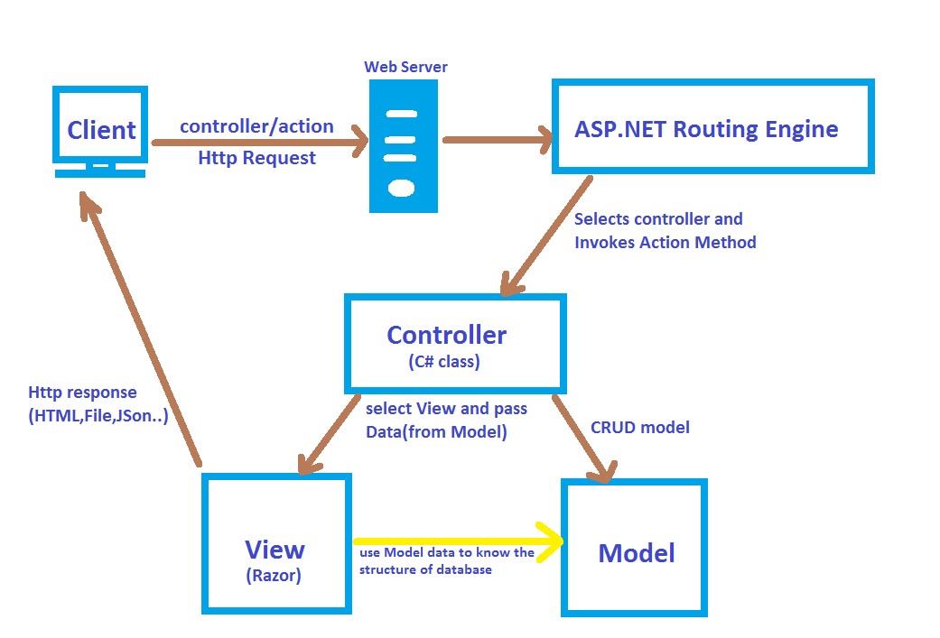

model view controller (layers are separated,efficient performance of server)

Model handles database,data layer

View handles presentation layer- UI

Controller🡺 Business logic

Interacting with model and view

Lifecycle of mvc

1.application 🡪

2.Request 🡪

**ROUTING IN ASP.NET MVC**

• **Routes** : It is a table which is collection of routes. When request comes , application first checks route table and matches the

route.

• **IgnoreRoute**: It a collection of URL that should be ignored by application.

• **MapRoute**:It is used to add new route into route table.

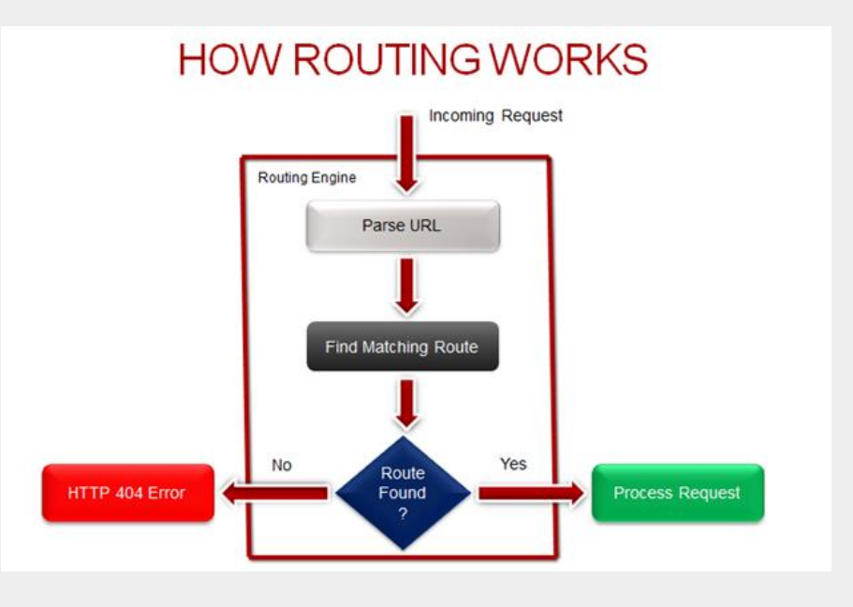

2 types of routing

1.Conventional Routing

2. Attribute Routing

**Attribute Routing**

• Attribute Routing gives you more control over URL in your Web Application.

• Using Attribute Routing we can have more readable URLs.

• To enable Attribute Routing

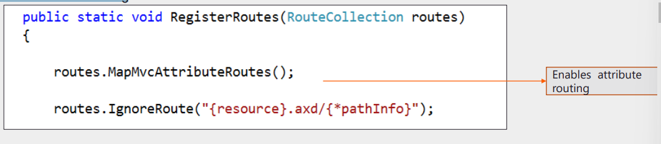

• Attribute Routing is configured before Convention Routing.

• We can use Convention based Routing and Attribute Routing in the same project

StopRoutingHandler Class

- Specifies ASP.NET Routing should not handle requests for given pattern

- It blocks Processing of given URL Request as Route

- Instead it is processed as an ASP.NET page, Web Service or ASP.NET endpoint.

**AREAS**

• To accommodate large projects ASP.NET MVC lets you partition Web Application into Smaller Units referred as Areas

• Using Areas we can separate a large MVC application into smaller functional groups.

• An application could contain several MVC areas.

**Constraints to prameters in Route**

Add below line in route.config in custom route

{parameter :Constraints}

{Id:int} or {id: int:min(1)}

New{ year=@”2015|2016”,month=@”\d{2}”}

Defining custom routes using attribute

To enable route attribute add below line in route.config

routes.MapMvcAttributeRoutes()

apply attribute in controller action

[Route(“url”)]

Ex: [Route(movies/released/{year}/{month:regex(\\d{4}:range(1,12))}”)]

Attribute route Constraints: min,max,minlength,maxlength,int,float,guid

Passing data to views:

Passing ViewData (it is a viewDataDictionary type)

ViewDate[“Movies”]=name of the var

@( ((Movie) ViewData[“Movie”]).Name)

Using ViewBag

View Model 🡪 adding models in a model

View-models may be used as an adapter or decorator, temporarily wrapping a model to provide additional information or to add formatting. This, however, is a dangerous practice and should be avoided whenever possible.

**Partial Views**

Large view into small views

@Html.Partial(“ViewName”,[model])

**FILTERS**

Filters are custom classes that provide both a declarative and programmatic means to add **pre-action and post-action** behavior to controller action methods.

Performs logic either before action method or after action method

**Types of Filters**

Authorization Filters − Implements the IAuthorizationFilter attribute.

Action Filters − Implements the IActionFilter attribute.

Result Filters − Implements the IResultFilter attribute.

Exception Filters − Implements the IExceptionFilter attribute.

Order of execution of filters is same as above list.i.e Aythorization Filter executes before Action Filter

**Action Filters**

An action filter is an attribute that you can apply to a controller action or an entire controller that modifies the way in which the action is executed. The ASP.NET MVC framework includes several action filters −

**OutputCache** − Caches the output of a controller action for a specified amount of time.

HandleError − Handles errors raised when a controller action is executed.

**Authorize** − Enables you to restrict access to a particular user or role.

MVC REQUEST LIFECYCLE

1. Starting point of MVC 5 Application: Application_Start (In Global.asax.cs)

- Performs Common Tasks such as Register Routes, bundles and filters.

2. URLRoutingModule class

- It is a class which matches an incoming HTTP Request to a registered route pattern in the RouteTable.

3. Controller Initialization :After finding matching Route next step is Controller initialization

MVCHandler is responsible for initiating the process using ProcessRequest() method.

4. Action Execution

*Model Binding*

- Retrieves data from incoming HTTP Request

- Do the data type conversions, data validations.

• Authentication Filter

- Used to Authenticate a User

• Authorization Filters

• Action Filters

- Executed before(OnActionExecuting) and after(OnActionExecuted) an action is executed

• When Action is executed, it prepares ActionResult.

Request Processing of ASP.NET MVC 5

• Result Execution: After Action Execution next step is Result Execution.

- Result Filters

• Executed before and after ActionResult is executed.

- Action Results

• Prepared by performing operations on user input with the help of Models.

• View Initialization and Rendering

